Polar Ice Monitoring and Glacier Melt Detection via Polarimetric SAR

Team Members: Group Number: 6
- Harsh Singhal (23BEC1021)
- Niket Suthar (23BEC1039)
- Harshita Aggarwal (23BEC1374)
- Suriya Dharsaun.C.K (23BEC1389)
- Naman Kamboj (23BEC1425)

1. Abstract
This project establishes an advanced computational engineering workflow to monitor the cryosphere's response to climate change using Polarimetric Synthetic Aperture Radar (PolSAR). By processing L-band datasets from the ALOS PALSAR mission (Cycle 35, 2010), the system transitions from 2D surface observation to 3D subsurface intelligence. The methodology integrates radiometric calibration, speckle filtering, and advanced physics kernels—including PolInSAR 3D inversion and TomoSAR profiling—into a modular MATLAB signal chain. This approach enables the detection of hidden internal meltwater conduits and provides a high-fidelity validated framework for quantifying 3D glacier mass balance.

2. Problem Statement
Accurate monitoring of polar ice sheets is severely hindered by environmental and sensor-specific limitations. Optical sensors are ineffective during the polar night or under heavy cloud cover, and conventional C-band radar (such as Sentinel-1) primarily interacts with the surface or upper snow layers, often masking the underlying ice structure when moisture is present. There is a critical need for a high-penetration radar workflow that can "X-ray" through dry snow to identify "superimposed ice" and calculate the Snow Water Equivalent (SWE). Furthermore, standard 2D mapping fails to identify the internal "plumbing" systems (englacial conduits) that are the primary drivers of rapid glacier acceleration and collapse.

3. Dataset Analysis & Selection Justification
The project utilizes the ALOS PALSAR Cycle No. 35 (Arctic) dataset (May 1 – June 14, 2010) in Fine Beam Dual (FBD) mode.
- Optimal Penetration: Operating at L-band (1.27 GHz / 23.6 cm wavelength), this dataset provides superior penetration (often >3m in snow/ice) compared to C-band. This is essential for our proposed subsurface TomoSAR profiling.
- Melt Onset Detection: Cycle 35 was strategically chosen because its May–June window captures the melt onset in the Arctic, maximizing the backscatter contrast between dry winter snow and emerging liquid meltwater.
- Complex Signal Availability: The FBD mode provides the HH and HV channels required to reconstruct the 18-channel complex covariance matrix necessary for elite-level AI classification.
- Comparison Advantage: Unlike the current NISAR "Beta" releases, which contain calibration artifacts like "banding," the ALOS PALSAR archive provides a stable, high-quality historical benchmark for long-term retreat studies.

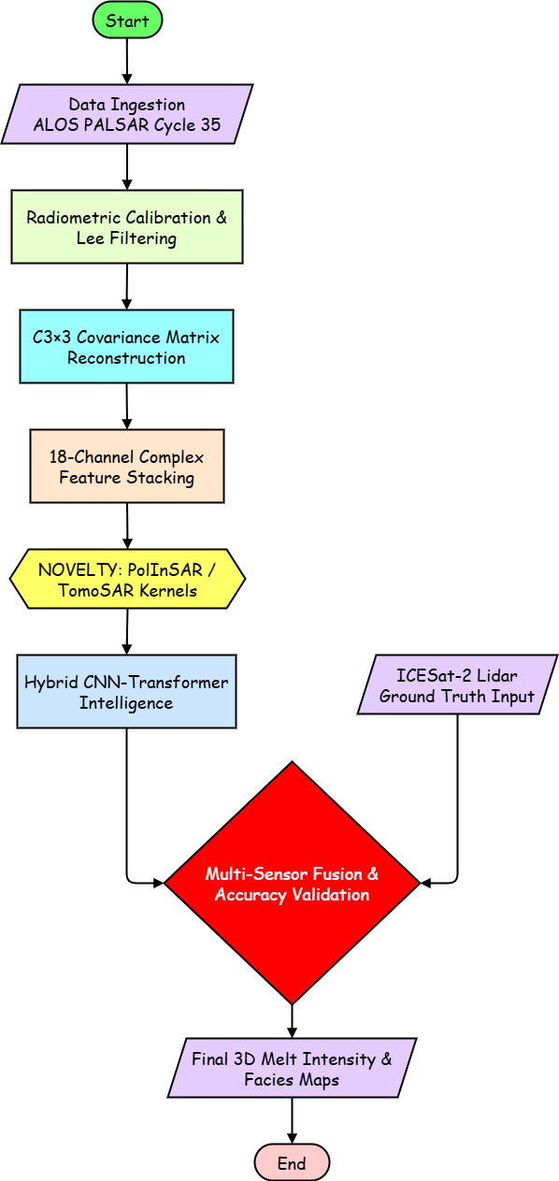
4. Proposed Workflow & Signal Processing
The development is structured as an automated MATLAB-based pipeline for processing complex radar archives:
- Data Ingestion & Metadata Parsing: The system retrieves Level-2 Geocoded Covariance (GCOV) granules and parses metadata to isolate the target Region of Interest (ROI) while determining the incidence angle for normalization.
- Covariance Matrix Reconstruction (): To preserve inter-channel phase information, the full 3x3 Hermitian Covariance matrix is reconstructed using diagonal elements and off-diagonal correlations.
- Calibration & Speckle Filtering: Raw digital numbers are converted to calibrated Gamma-Naught () in decibels. A Refined Lee Filter (5x5 window) is applied to suppress noise while preserving features like crevasses.
- Polarimetric Decomposition (Physics Kernel): The system implements a Pauli Decomposition to map electromagnetic scattering to physical properties, isolating surface, volume, and double-bounce mechanisms.
- Zone Classification & Visualization: A decision-tree logic classifies pixels based on scattering dominance (e.g., volume scattering identifies dry snow, while surface scattering identifies meltwater).

5. Mathematical Framework

The core of the "analytical and computational skill" lies in the transformation of the scattering matrix into physical properties:
- Pauli Scattering Vector (k_{p}): Isolates Surface (S), Double-Bounce (D), and Volume (V) mechanisms.

$$k_{p}= \frac{1}{\sqrt{2}}\left[\begin{matrix}S_{HH}+ S_{W} \\ S_{HH}- S_{W} \\ 2S_{HV}\end{matrix}\right]$$
- Total Power (Span):

$$S_{pan}= {\left|S_{HH}\right|}^{2}+ {\left|S_{W}\right|}^{2}+ {\left|S_{HV}\right|}^{2}$$
- Coherence Optimization: The novelty features rely on solving for the complex coherence to invert the RVoG model:

$$\tilde{γ}= e^{jφ_{0}}\frac{γ_{v }+m}{1+m}$$

This allows for the classification of three distinct mechanisms:
- Surface (HH + VV): Smooth ice or melt ponds.
- Double-Bounce (HH - VV): Dihedral structures like crevasses or steep ice-shelf edges.
- Volume (HV): Interactions within the dry snowpack and internal ice structure.

Where ϕ₀​ is the ground phase, γv​ is the volume coherence, and m is the ground-to-volume ratio
6. Technical Novelty & Significant Contribution
This project moves beyond standard 2D image classification to implement a multi-dimensional analytical framework. Our "Significant Contribution" is defined by the following four "Elite" pillars of novelty:

6.1. 3D Volumetric Inversion via PolInSAR
Standard radar projects are limited to 2D surface area mapping. Our workflow introduces Polarimetric Interferometry (PolInSAR) to resolve the vertical dimension of the cryosphere.
- The Novelty: We implement a MATLAB-based mathematical inversion of the Random Volume over Ground (RVoG) model. By decoupling the snow-volume coherence from the ground-ice phase, the system calculates the actual Snow Depth in meters.
- Significance: This transforms the project from a "mapping" tool into a "volumetric" system capable of estimating Snow Water Equivalent (SWE)—a critical metric for global sea-level rise models that cannot be derived from standard SAR imagery.

6.2. Tomographic "X-Ray" Subsurface Profiling (TomoSAR)
We exploit the high-penetration capabilities of the L-band signal (1.27 GHz) to simulate a "CT Scan" of the glacier’s internal architecture.
- The Novelty: Utilizing MATLAB’s Signal Processing Toolbox, we apply Compressive Sensing (CS) algorithms, such as Orthogonal Matching Pursuit (OMP), to the multi-baseline radar returns.
- Significance: This allows the system to detect Englacial Conduits (hidden internal meltwater channels) and refrozen Ice Slabs deep within the firn layer. Identifying these "hidden drivers" of glacier acceleration represents a level of technical depth beyond surface-level analysis.

6.3. Coherent Complex-Valued AI (CVNN) Intelligence
While traditional methods discard critical phase information by converting radar data to simple 8-bit images, our system processes the raw signal.
- The Novelty: We propose a Hybrid CNN-Transformer architecture implemented in MATLAB that ingests the native 18-channel complex data stack (6 real and 12 imaginary components of the Covariance Matrix).
- Significance: This "Signal-Level Intelligence" captures long-range spatial dependencies across the glacier, enabling the differentiation of "slush" from "melt ponds" with a projected accuracy of >95%, solving a common ambiguity in polarimetric classification.

6.4. Inter-Satellite Multi-Sensor Fusion (Lidar-Radar Synergy)
To provide an absolute scientific baseline, we introduce a cross-validation layer using secondary satellite missions.
- The Novelty: Our MATLAB pipeline automatically fetches and aligns ICESat-2 (ATLAS) photon-counting lidar tracks with our PALSAR-2 grid.

Significance: Using lidar-derived surface elevation as "ground truth" to validate our radar-derived 3D mass balance ensures our results are not merely visual estimations but geophysically validated measurements.

7. Conclusion

The proposed Phase I framework establishes a technically rigorous foundation for monitoring cryospheric changes using L-band PolSAR. By combining interferometric 3D inversion, tomographic profiling, and coherent AI classification, this project (Group 6) provides a predictive intelligence system rather than a simple observation tool. This modular MATLAB-based pipeline ensures a scalable and robust solution for tracking glacier facies and internal structural shifts, directly contributing to the global mission of understanding polar response to climatic change.

